企业填报数据对外接口(开放给企业第三方应用接入)

前言
该文档介绍的接口是企业用户在数据采集上报的时候，想把该地方的接口集成到自己公司的平台时使用的接口。简单来说，就是使用中服云经济监测运行平台，当你想要上报政府给的报表时，需要登录平台后手动去填报报表数据。为了方便企业用户的使用，给出了以下的接口可以直接调用来完成上报查看工作。这样可以将接口集成到企业的第三方系统中。

功能介绍
先介绍一下接口实现的功能，企业按照报表周期，例如每个月需要给政府上报上月的产值和财务，而这也可以认为是两张报表，围绕着这两张报表的上报，修改，查询实现了以下的接口。
在介绍之前先简单说一下查询的前缀，当你使用的是公司平台的多租户系统时，每个租户都会有一个二级域名，很明显就在主域名的前面，比如：
http://2a2ccn40100002dc0.gyjjjc.cserver.com.cn
前面的一串2a2ccn40100002dc0就是该租户的二级域名，你在调用接口的时候就需要加上二级域名去调用，否则会访问不到。
当然也有可能独立部署的系统，那么就不需要二级域名。在调用时请确认好系统版本，如无法确认，请与公司工作人员联系。

接口前缀需要确认，域名目前无法知道。
接口返回值格式为：
{
"code": 200,
"msg": "执行成功！",
"data": {},
"status": true
}
分页使用PageHepler，如果有分页则数据都在data中。

1、查询企业报表
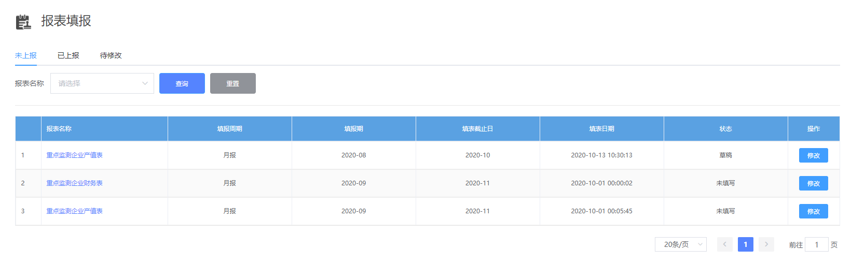
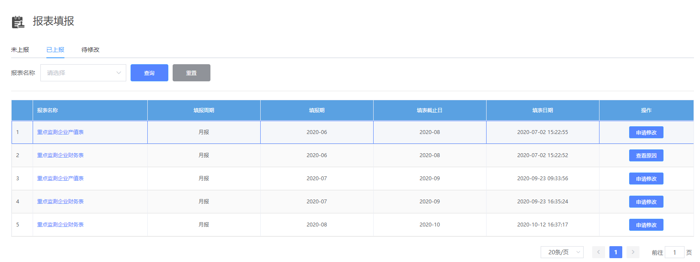
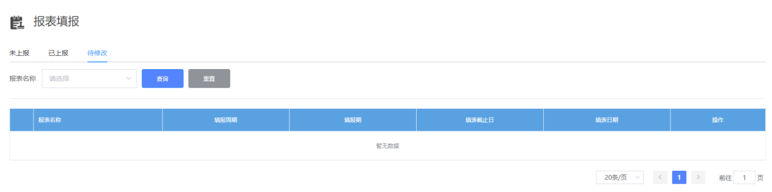
图1-1
就是查询图中的列表
接口：
GET请求：/companyForm/selectForm
参数：
loginName: 企业用户的登录名(统一社会信用代码) 必传
code：报表code(产值表:001,财务表:002)，不传则查询全部
type：查询类型(0-未上报,1-已上报,2-待修改) 必传
pageNum：当前页 有默认值
pageSize：每页个数 有默认值
接口功能：
查询企业未上报，已上报以及待修改的报表列表
接口展示：
http://localhost:8776/business/companyForm/selectForm?loginName=00017845145724&type=0&pageNum=1&pageSize=10
返回值：
{
"code": 200,
"msg": "执行成功！",
"data": {
"pageNum": 1,
"pageSize": 3,
"size": 3,
"startRow": 0,
"endRow": 2,
"total": 3,
"pages": 1,
"list": [
{
"id": "b227b697-a6d4-48a7-93a6-cff1aba7d96d",
"code": "001",
"name": "重点监测企业产值表",
"report_cycle": 0,
"date_range": "2020-08",
"date_range_end": "2020-10",
"sqxg_status": "0",
"status": "1",
"company": "a5a01c6665114bce94e53e815f05ef97",
"company_name": "工业经济运行监测测试企业",
"region_code": "632801",
"region": "格尔木市",
"user_name": "工业经济运行监测测试企业",
"login_name": "00017845145724",
"crt_time": "2020-10-13T02:30:13.000+0000",
"count": 0,
"apply_time": "2020-09-03T03:02:27.000+0000",
"handle_time": "2020-09-03T03:02:27.000+0000",
"apply_reason": "",
"handle_reason": "",
"report_yidong": 0
}
],
"prePage": 0,
"nextPage": 0,
"isFirstPage": true,
"isLastPage": true,
"hasPreviousPage": false,
"hasNextPage": false,
"navigatePages": 8,
"navigatepageNums": [
1
],
"navigateFirstPage": 1,
"navigateLastPage": 1,
"lastPage": 1,
"firstPage": 1
},
"status": true
}
数据为data.list，字段与下表对应
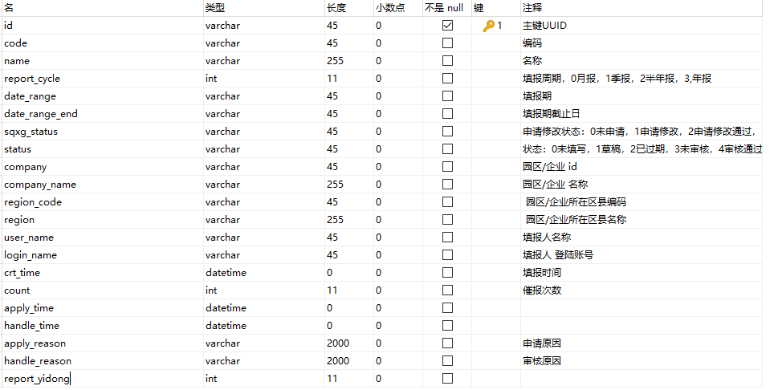

2、查询企业财务表信息
注意：
财务表和产值表在查询报表时是不同的接口，根据接口1查询企业报表返回的字段code进行判断，001为产值表，002为财务表。
查询列表完成之后，需要对上报列表中的填报信息进行查看，该接口就是查看财务表信息的，如上图1-1，点击报表名称，查看填报信息，点击后面修改，查看的同时可以进行数据填报，然后选择存为草稿或者上报报表。
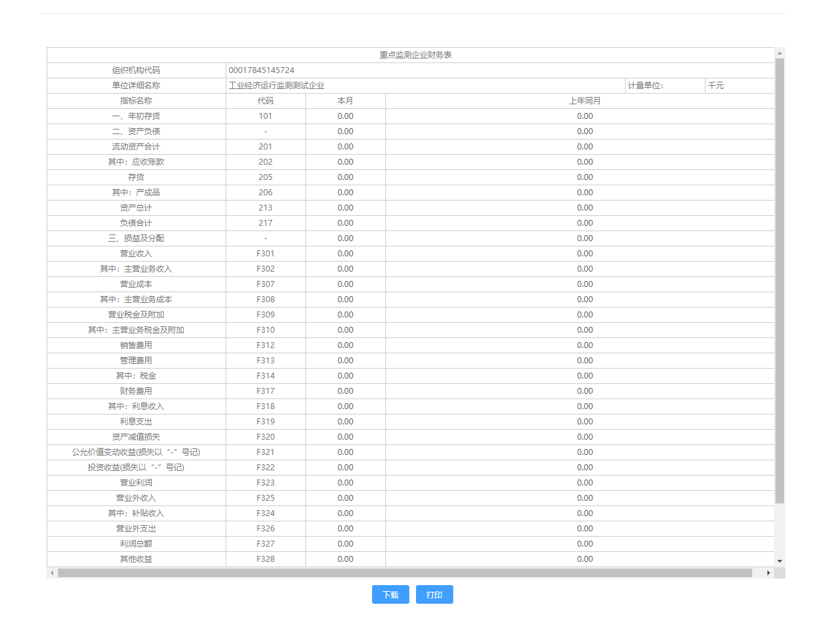
接口：
GET请求：companyForm/selectCompanyFinancialForm
参数：
id: 查询报表的id主键（上面接口查询企业报表返回的id）
接口功能：
根据主键id查询企业财务表信息
接口展示：
http://localhost:8776/business /companyForm/selectCompanyFinancialForm?id=3e6d47eb-d9ae-4ea9-854d-590d73d2f6c8

返回值：
{
"code": 200,
"msg": "执行成功！",
"data": {
"financialListMsg": [
{
"id": "baf9913b-33c4-4988-a1b2-c1ac017906e1",
"code": "101",
"name": "一、年初存货",
"this_month": 0,
"last_year_month": 0,
"zdjcqycwb_id": "21e7369b-5316-4b66-895c-5c08a72836d5",
"row": 1,
"date_range": "2020-09",
"month_query": "09",
"year_query": "2020",
"quarter_query": "3"
},
{
"id": "fc0f8ca5-463a-41ca-9a7f-2112ca0cd3b5",
"code": "-",
"name": "二、资产负债",
"this_month": 0,
"last_year_month": 0,
"zdjcqycwb_id": "21e7369b-5316-4b66-895c-5c08a72836d5",
"row": 2,
"date_range": "2020-09",
"month_query": "09",
"year_query": "2020",
"quarter_query": "3"
},
{
"id": "783e72f9-4c2f-452f-8082-3a5b1fbe952e",
"code": "201",
"name": "流动资产合计",
"this_month": 0,
"last_year_month": 0,
"zdjcqycwb_id": "21e7369b-5316-4b66-895c-5c08a72836d5",
"row": 3,
"date_range": "2020-09",
"month_query": "09",
"year_query": "2020",
"quarter_query": "3"
},
{
"id": "6b956034-7360-4875-a100-2f44077f772a",
"code": "202",
"name": "其中：应收账款",
"this_month": 0,
"last_year_month": 0,
"zdjcqycwb_id": "21e7369b-5316-4b66-895c-5c08a72836d5",
"row": 4,
"date_range": "2020-09",
"month_query": "09",
"year_query": "2020",
"quarter_query": "3"
},
{
"id": "a7a84d54-1883-40a2-a0e7-446cf90957f4",
"code": "205",
"name": "存货",
"this_month": 0,
"last_year_month": 0,
"zdjcqycwb_id": "21e7369b-5316-4b66-895c-5c08a72836d5",
"row": 5,
"date_range": "2020-09",
"month_query": "09",
"year_query": "2020",
"quarter_query": "3"
},
{
"id": "ee3d7e0f-fa84-4728-8c1a-8db06324816e",
"code": "206",
"name": "其中：产成品",
"this_month": 0,
"last_year_month": 0,
"zdjcqycwb_id": "21e7369b-5316-4b66-895c-5c08a72836d5",
"row": 6,
"date_range": "2020-09",
"month_query": "09",
"year_query": "2020",
"quarter_query": "3"
},
{
"id": "5b213059-a224-4317-b814-d78361f8b250",
"code": "213",
"name": "资产总计",
"this_month": 0,
"last_year_month": 0,
"zdjcqycwb_id": "21e7369b-5316-4b66-895c-5c08a72836d5",
"row": 7,
"date_range": "2020-09",
"month_query": "09",
"year_query": "2020",
"quarter_query": "3"
},
{
"id": "fb26c1e3-6acf-4be9-a722-1d4489daf483",
"code": "217",
"name": "负债合计",
"this_month": 0,
"last_year_month": 0,
"zdjcqycwb_id": "21e7369b-5316-4b66-895c-5c08a72836d5",
"row": 8,
"date_range": "2020-09",
"month_query": "09",
"year_query": "2020",
"quarter_query": "3"
},
{
"id": "d2c2c9e6-1a81-418b-afc2-a00223ca5b14",
"code": "-",
"name": "三、损益及分配",
"this_month": 0,
"last_year_month": 0,
"zdjcqycwb_id": "21e7369b-5316-4b66-895c-5c08a72836d5",
"row": 9,
"date_range": "2020-09",
"month_query": "09",
"year_query": "2020",
"quarter_query": "3"
},
{
"id": "bbca0529-aaa3-4450-bd52-4b3700170a34",
"code": "F301",
"name": "营业收入",
"this_month": 0,
"last_year_month": 0,
"zdjcqycwb_id": "21e7369b-5316-4b66-895c-5c08a72836d5",
"row": 10,
"date_range": "2020-09",
"month_query": "09",
"year_query": "2020",
"quarter_query": "3"
},
{
"id": "740d06ea-f885-4ff7-bad0-eb1619e39c1b",
"code": "F302",
"name": "其中：主营业务收入",
"this_month": 0,
"last_year_month": 0,
"zdjcqycwb_id": "21e7369b-5316-4b66-895c-5c08a72836d5",
"row": 11,
"date_range": "2020-09",
"month_query": "09",
"year_query": "2020",
"quarter_query": "3"
},
{
"id": "398d9243-5e23-4e61-8604-6002f0826550",
"code": "F307",
"name": "营业成本",
"this_month": 0,
"last_year_month": 0,
"zdjcqycwb_id": "21e7369b-5316-4b66-895c-5c08a72836d5",
"row": 12,
"date_range": "2020-09",
"month_query": "09",
"year_query": "2020",
"quarter_query": "3"
},
{
"id": "a437382c-9980-47cc-930a-d04c301bf3e6",
"code": "F308",
"name": "其中：主营业务成本",
"this_month": 0,
"last_year_month": 0,
"zdjcqycwb_id": "21e7369b-5316-4b66-895c-5c08a72836d5",
"row": 13,
"date_range": "2020-09",
"month_query": "09",
"year_query": "2020",
"quarter_query": "3"
},
{
"id": "947a7f02-d7f4-4306-8963-1811f00da31e",
"code": "F309",
"name": "营业税金及附加",
"this_month": 0,
"last_year_month": 0,
"zdjcqycwb_id": "21e7369b-5316-4b66-895c-5c08a72836d5",
"row": 14,
"date_range": "2020-09",
"month_query": "09",
"year_query": "2020",
"quarter_query": "3"
},
{
"id": "223cad4a-4e4d-4734-8574-cd2bd1f41229",
"code": "F310",
"name": "其中：主营业务税金及附加",
"this_month": 0,
"last_year_month": 0,
"zdjcqycwb_id": "21e7369b-5316-4b66-895c-5c08a72836d5",
"row": 15,
"date_range": "2020-09",
"month_query": "09",
"year_query": "2020",
"quarter_query": "3"
},
{
"id": "e3946e0d-e729-44d7-96ce-62d01f7de5af",
"code": "F312",
"name": "销售费用",
"this_month": 0,
"last_year_month": 0,
"zdjcqycwb_id": "21e7369b-5316-4b66-895c-5c08a72836d5",
"row": 16,
"date_range": "2020-09",
"month_query": "09",
"year_query": "2020",
"quarter_query": "3"
},
{
"id": "e84b915f-a8fb-46f6-ad86-b660ab67150d",
"code": "F313",
"name": "管理费用",
"this_month": 0,
"last_year_month": 0,
"zdjcqycwb_id": "21e7369b-5316-4b66-895c-5c08a72836d5",
"row": 17,
"date_range": "2020-09",
"month_query": "09",
"year_query": "2020",
"quarter_query": "3"
},
{
"id": "b9467999-9fb7-4737-8247-82ee3a977590",
"code": "F314",
"name": "其中：税金",
"this_month": 0,
"last_year_month": 0,
"zdjcqycwb_id": "21e7369b-5316-4b66-895c-5c08a72836d5",
"row": 18,
"date_range": "2020-09",
"month_query": "09",
"year_query": "2020",
"quarter_query": "3"
},
{
"id": "5473d2fe-4d35-43f4-af2a-96f7ee9561b2",
"code": "F317",
"name": "财务费用",
"this_month": 0,
"last_year_month": 0,
"zdjcqycwb_id": "21e7369b-5316-4b66-895c-5c08a72836d5",
"row": 19,
"date_range": "2020-09",
"month_query": "09",
"year_query": "2020",
"quarter_query": "3"
},
{
"id": "e82246c0-2382-4e16-83c0-121957778317",
"code": "F318",
"name": "其中：利息收入",
"this_month": 0,
"last_year_month": 0,
"zdjcqycwb_id": "21e7369b-5316-4b66-895c-5c08a72836d5",
"row": 20,
"date_range": "2020-09",
"month_query": "09",
"year_query": "2020",
"quarter_query": "3"
},
{
"id": "c5ccb449-1410-46c2-8660-8e2182dfe68d",
"code": "F319",
"name": "利息支出",
"this_month": 0,
"last_year_month": 0,
"zdjcqycwb_id": "21e7369b-5316-4b66-895c-5c08a72836d5",
"row": 21,
"date_range": "2020-09",
"month_query": "09",
"year_query": "2020",
"quarter_query": "3"
},
{
"id": "d63fc75f-ce09-42a3-bcdc-968de1a695b8",
"code": "F320",
"name": "资产减值损失",
"this_month": 0,
"last_year_month": 0,
"zdjcqycwb_id": "21e7369b-5316-4b66-895c-5c08a72836d5",
"row": 22,
"date_range": "2020-09",
"month_query": "09",
"year_query": "2020",
"quarter_query": "3"
},
{
"id": "9707f6b1-50cc-4171-951a-1eaa73e49eb7",
"code": "F321",
"name": "公允价值变动收益(损失以“-”号记)",
"this_month": 0,
"last_year_month": 0,
"zdjcqycwb_id": "21e7369b-5316-4b66-895c-5c08a72836d5",
"row": 23,
"date_range": "2020-09",
"month_query": "09",
"year_query": "2020",
"quarter_query": "3"
},
{
"id": "7031a1db-6c9d-4b07-b22c-b7af524352da",
"code": "F322",
"name": "投资收益(损失以“-”号记)",
"this_month": 0,
"last_year_month": 0,
"zdjcqycwb_id": "21e7369b-5316-4b66-895c-5c08a72836d5",
"row": 24,
"date_range": "2020-09",
"month_query": "09",
"year_query": "2020",
"quarter_query": "3"
},
{
"id": "0e18a694-d406-4b4d-9452-efec320ca956",
"code": "F323",
"name": "营业利润",
"this_month": 0,
"last_year_month": 0,
"zdjcqycwb_id": "21e7369b-5316-4b66-895c-5c08a72836d5",
"row": 25,
"date_range": "2020-09",
"month_query": "09",
"year_query": "2020",
"quarter_query": "3"
},
{
"id": "a4682b29-bb9f-45dc-a98f-592bbfea3983",
"code": "F325",
"name": "营业外收入",
"this_month": 0,
"last_year_month": 0,
"zdjcqycwb_id": "21e7369b-5316-4b66-895c-5c08a72836d5",
"row": 26,
"date_range": "2020-09",
"month_query": "09",
"year_query": "2020",
"quarter_query": "3"
},
{
"id": "2514e5a5-0c6a-4329-b282-5ada7fe09552",
"code": "F324",
"name": "其中：补贴收入",
"this_month": 0,
"last_year_month": 0,
"zdjcqycwb_id": "21e7369b-5316-4b66-895c-5c08a72836d5",
"row": 27,
"date_range": "2020-09",
"month_query": "09",
"year_query": "2020",
"quarter_query": "3"
},
{
"id": "1f1f22aa-5ad3-4dab-b3fc-c62b6e71618d",
"code": "F326",
"name": "营业外支出",
"this_month": 0,
"last_year_month": 0,
"zdjcqycwb_id": "21e7369b-5316-4b66-895c-5c08a72836d5",
"row": 28,
"date_range": "2020-09",
"month_query": "09",
"year_query": "2020",
"quarter_query": "3"
},
{
"id": "f631cbda-4ece-4474-ab5d-3d216b078ee4",
"code": "F327",
"name": "利润总额",
"this_month": 0,
"last_year_month": 0,
"zdjcqycwb_id": "21e7369b-5316-4b66-895c-5c08a72836d5",
"row": 29,
"date_range": "2020-09",
"month_query": "09",
"year_query": "2020",
"quarter_query": "3"
},
{
"id": "dc793a0b-8b26-442d-8ab7-a7b79b55d137",
"code": "F328",
"name": "其他收益",
"this_month": 0,
"last_year_month": 0,
"zdjcqycwb_id": "21e7369b-5316-4b66-895c-5c08a72836d5",
"row": 30,
"date_range": "2020-09",
"month_query": "09",
"year_query": "2020",
"quarter_query": "3"
},
{
"id": "d37413e4-f6cc-4451-9748-a1698d0cc8a7",
"code": "F402",
"name": "四、应交增值税",
"this_month": 0,
"last_year_month": 0,
"zdjcqycwb_id": "21e7369b-5316-4b66-895c-5c08a72836d5",
"row": 31,
"date_range": "2020-09",
"month_query": "09",
"year_query": "2020",
"quarter_query": "3"
},
{
"id": "6f6dcbb2-bfca-4a25-940b-b358dee9fc5e",
"code": "606",
"name": "五、平均用工人数(人)",
"this_month": 0,
"last_year_month": 0,
"zdjcqycwb_id": "21e7369b-5316-4b66-895c-5c08a72836d5",
"row": 32,
"date_range": "2020-09",
"month_query": "09",
"year_query": "2020",
"quarter_query": "3"
}
],
"financialMainMsg": {
"id": "21e7369b-5316-4b66-895c-5c08a72836d5",
"code": "00017845145724",
"name": "工业经济运行监测测试企业",
"date_range": "2020-09",
"duty_person": "",
"count_person": "",
"insert_person": "",
"phone": "",
"insert_date": "2020-10-01",
"doc_id": "3e6d47eb-d9ae-4ea9-854d-590d73d4f6b8",
"month_query": "09",
"year_query": "2020",
"quarter_query": "3",
"unit": "千元"
}
},
"status": true
}

表数据比较多，主要分为两部分：
financialMainMsg：返回主体信息
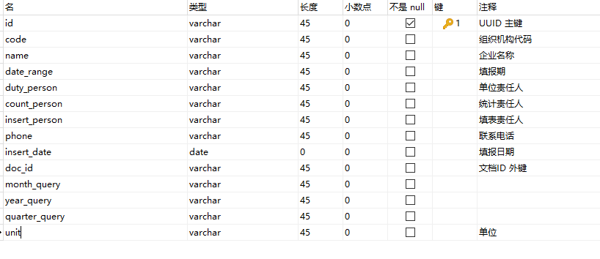
financialListMsg：返回指标信息
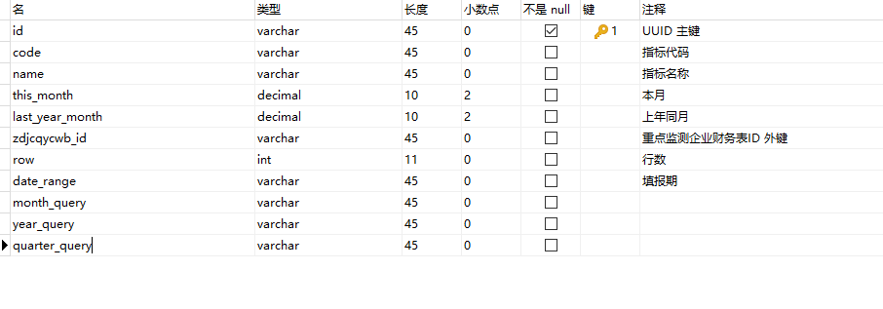

3、查询企业产值表信息
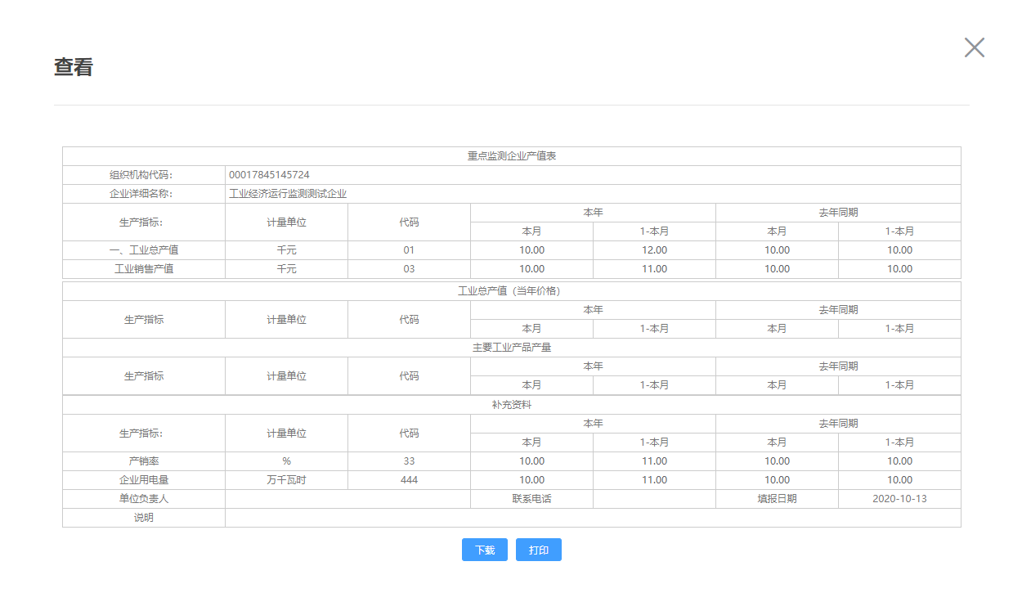
产值表和上面的财务表功能类似，只是返回值的不同
接口：
GET请求：companyForm/selectCompanyOutputForm
参数：
id: 查询报表的id主键（上面接口查询企业报表返回的id）
接口功能：
根据主键id查询企业产值表信息
接口展示：
http://localhost:8776/ business /companyForm/selectCompanyOutputForm?id=b227b697-a6d4-48a7-93a6-cff1bbc7c96d

返回值：
{
"code": 200,
"msg": "执行成功！",
"data": {
"output1List": [],
"outputMainMsg": {
"id": "46adc486-1b58-4fbb-b2c0-c278a4157bdc",
"code": "00017845145724",
"name": "工业经济运行监测测试企业",
"date_range": "2020-08",
"duty_person": "",
"duty_phone": "",
"create_time": "2020-10-13",
"doc_id": "b227b697-a6d4-48a7-93a6-cff1aba7d96d",
"row": 0,
"month_query": "08",
"year_query": "2020",
"quarter_query": "3",
"des": ""
},
"output0List": [
{
"id": "4dfafc9a-7c1b-4382-9c4e-4c31a4fbf1b7",
"code": "01",
"name": "一、工业总产值",
"unit": "千元",
"month_this": 10,
"month_this1": 12,
"month_last": 10,
"month_last1": 10,
"zdjcqyczb_id": "46adc486-1b58-4fbb-b2c0-c278a4157bdc",
"row": 1,
"date_range": "2020-08",
"month_query": "08",
"year_query": "2020",
"quarter_query": "3"
},
{
"id": "d39979f8-8552-4f71-b745-b3aea0e8e0aa",
"code": "03",
"name": "工业销售产值",
"unit": "千元",
"month_this": 10,
"month_this1": 11,
"month_last": 10,
"month_last1": 10,
"zdjcqyczb_id": "46adc486-1b58-4fbb-b2c0-c278a4157bdc",
"row": 2,
"date_range": "2020-08",
"month_query": "08",
"year_query": "2020",
"quarter_query": "3"
}
],
"output3List": [
{
"id": "b7f0d136-aab7-4c54-b946-9142907342d9",
"code": "33",
"name": "产销率",
"unit": "%",
"month_this": 10,
"month_this1": 11,
"month_last": 10,
"month_last1": 10,
"zdjcqyczb_id": "46adc486-1b58-4fbb-b2c0-c278a4157bdc",
"row": 1,
"date_range": "2020-08",
"month_query": "08",
"year_query": "2020",
"quarter_query": "3"
},
{
"id": "f0a5371e-bc95-47e3-9fb4-c6e0255136d8",
"code": "444",
"name": "企业用电量",
"unit": "万千瓦时",
"month_this": 10,
"month_this1": 11,
"month_last": 10,
"month_last1": 10,
"zdjcqyczb_id": "46adc486-1b58-4fbb-b2c0-c278a4157bdc",
"row": 2,
"date_range": "2020-08",
"month_query": "08",
"year_query": "2020",
"quarter_query": "3"
}
],
"output2List": []
},
"status": true
}
这块里面比较复杂，分为了五个部分：
outputMainMsg：
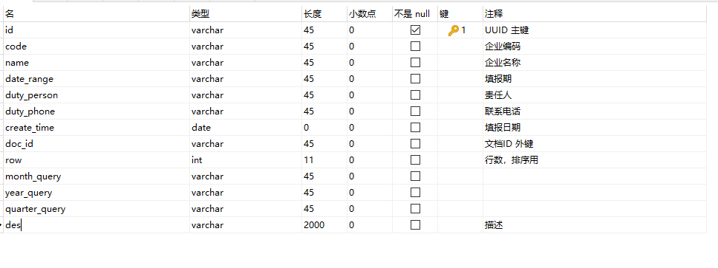
output0List
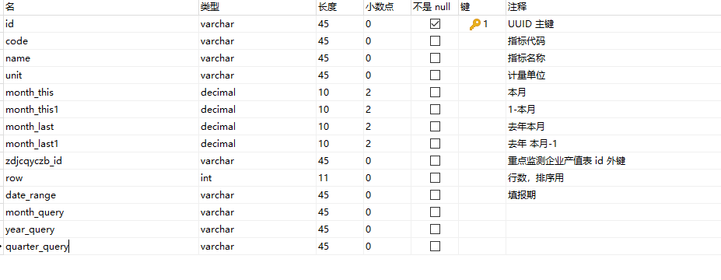
output1List
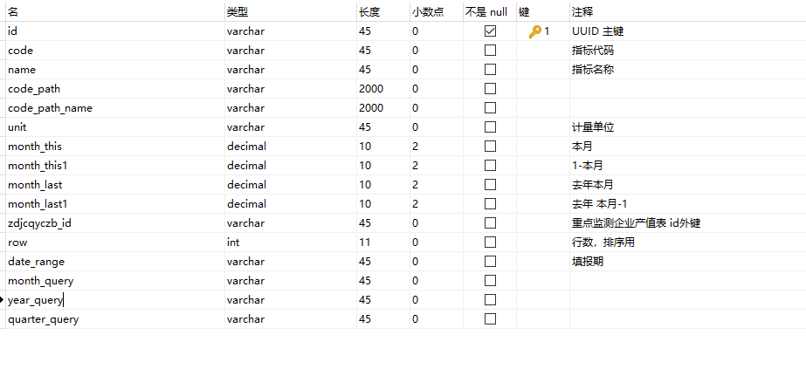
output2List
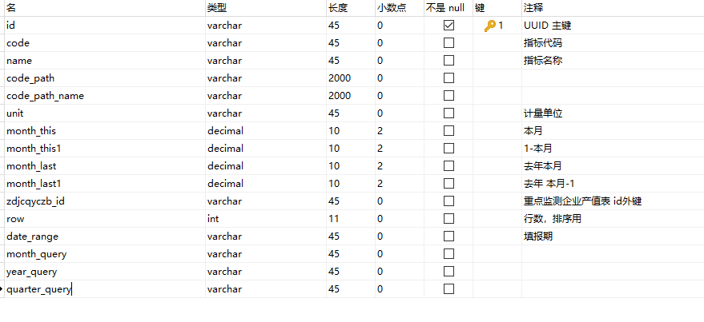
output3List
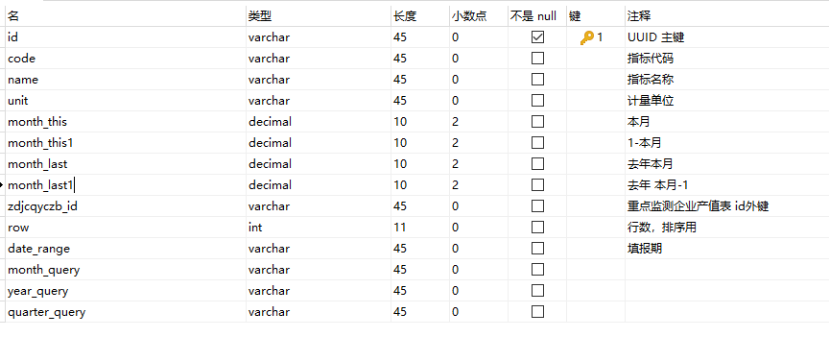

上面的main，0，1，2，3数据分别对应下表中标注的位置数据
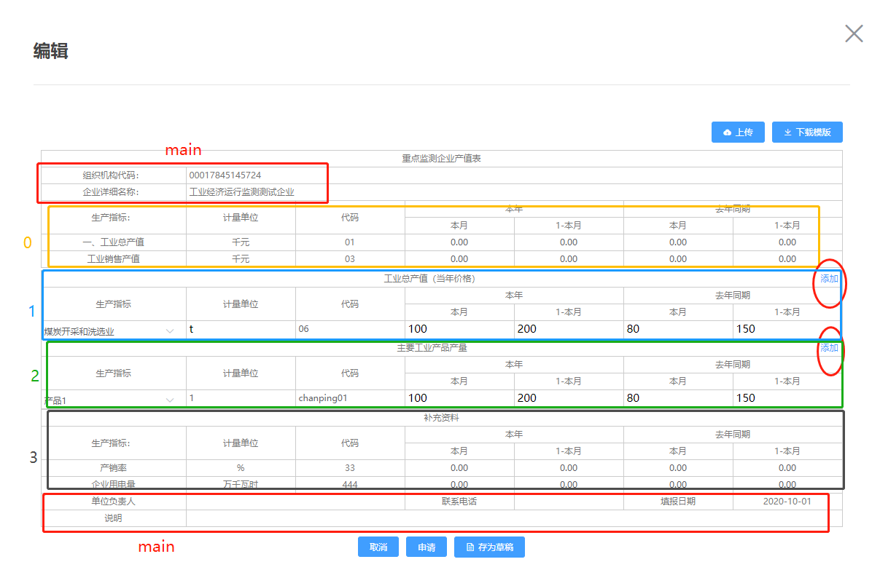

4、企业财务表填报
企业财务填报主要功能是企业用户在查询未上报或者待修改的报表后，填写完成数据，进行下列的操作，由于数据较多，所以该接口需要传的数据也是很多的。
而传递的接口格式是跟上面两个接口，即查询出来的企业财务表和企业产值表相同。
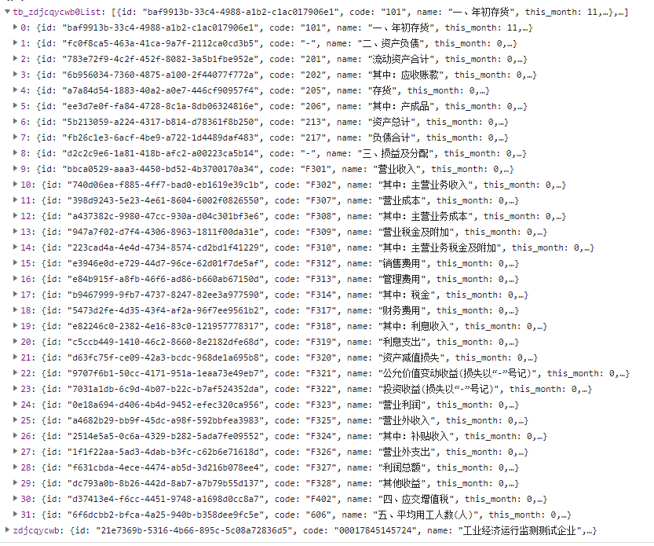
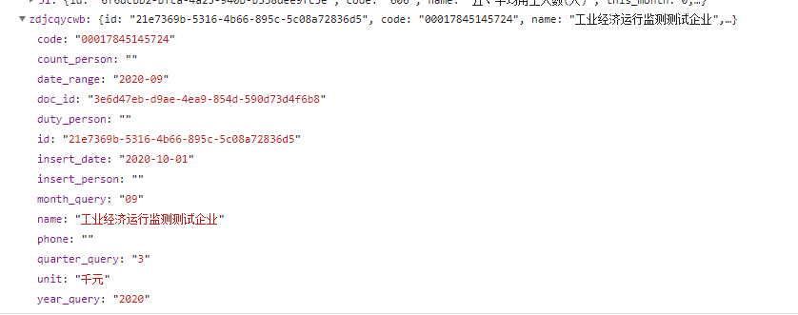
此为传入的数据，注意key和上面不同，zdjcqycwb改为financialMainMsg，tb_zdjcqycwb0List改为financialListMsg
另外还需要传入type类型type:0-存为草稿,1-上报,2-待修改
综合下来这个接口如下：
PUT：http://localhost:8776/business/companyForm/updateCompanyFinancialForm
传入参数为：

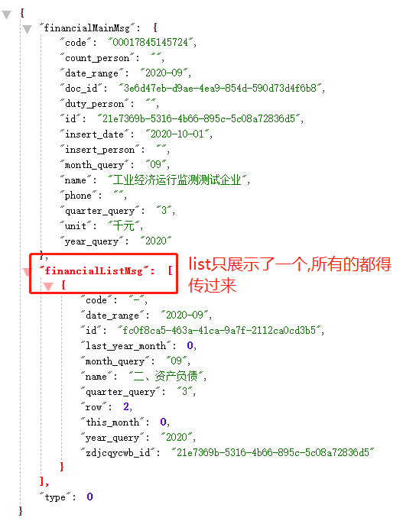
{
"financialMainMsg": {
"code": "00017845145724",
"count_person": "",
"date_range": "2020-09",
"doc_id": "3e6d47eb-d9ae-4ea9-854d-590d73d4f6b8",
"duty_person": "",
"id": "21e7369b-5316-4b66-895c-5c08a72836d5",
"insert_date": "2020-10-01",
"insert_person": "",
"month_query": "09",
"name": "工业经济运行监测测试企业",
"phone": "",
"quarter_query": "3",
"unit": "千元",
"year_query": "2020"
},
"financialListMsg": [
{
"code": "-",
"date_range": "2020-09",
"id": "fc0f8ca5-463a-41ca-9a7f-2112ca0cd3b5",
"last_year_month": 0,
"month_query": "09",
"name": "二、资产负债",
"quarter_query": "3",
"row": 2,
"this_month": 0,
"year_query": "2020",
"zdjcqycwb_id": "21e7369b-5316-4b66-895c-5c08a72836d5"
}
],
"type": 0
}
使用的场景:
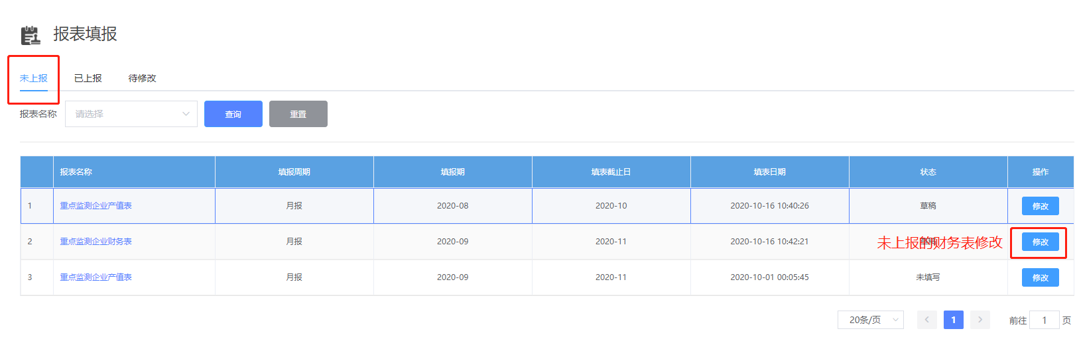
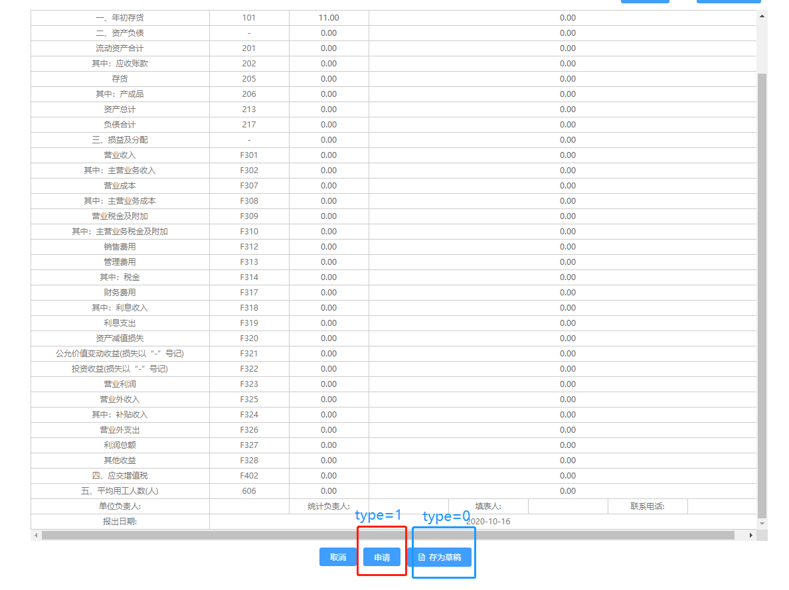
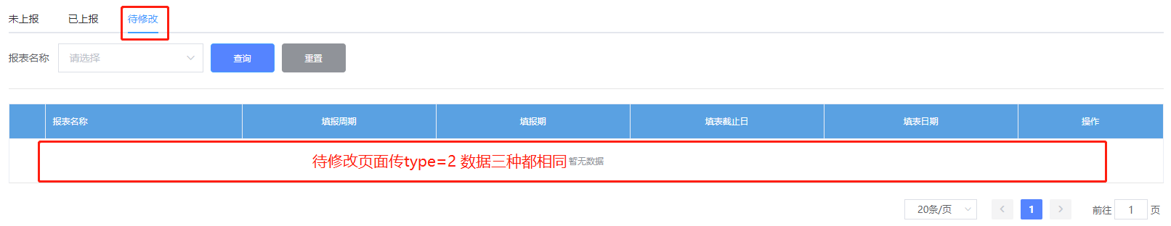

5、企业产值表填报
产值表和财务表填报大同小异，我主要介绍接口和传参。
接口：
PUT：http://localhost:8776/business/companyForm/updateCompanyOutputForm
传入参数为：
{
"type": 0,
"outputMainMsg": {
"code": "00017845145724",
"create_time": "2020-10-16",
"date_range": "2020-08",
"des": "",
"doc_id": "b227b697-a6d4-48a7-93a6-cff1aba7d96d",
"duty_person": "",
"duty_phone": "",
"id": "46adc486-1b58-4fbb-b2c0-c278a4157bdc",
"month_query": "08",
"name": "工业经济运行监测测试企业",
"quarter_query": "3",
"row": 0,
"year_query": "2020"
},
"output0List": [
{
"code": "01",
"date_range": "2020-08",
"id": "4dfafc9a-7c1b-4382-9c4e-4c31a4fbf1b7",
"month_last": 10,
"month_last1": 10,
"month_query": "08",
"month_this": 10,
"month_this1": 12,
"name": "一、工业总产值",
"quarter_query": "3",
"row": 1,
"unit": "千元",
"year_query": "2020",
"zdjcqyczb_id": "46adc486-1b58-4fbb-b2c0-c278a4157bdc"
},
{
"code": "03",
"date_range": "2020-08",
"id": "d39979f8-8552-4f71-b745-b3aea0e8e0aa",
"month_last": 10,
"month_last1": 10,
"month_query": "08",
"month_this": 10,
"month_this1": 11,
"name": "工业销售产值",
"quarter_query": "3",
"row": 2,
"unit": "千元",
"year_query": "2020",
"zdjcqyczb_id": "46adc486-1b58-4fbb-b2c0-c278a4157bdc"
}
],
"output1List": [
{
"code": "06",
"code_path": [
"06"
],
"code_path_name": [
"煤炭开采和洗选业"
],
"id": "",
"month_last": "80",
"month_last1": "300",
"month_this": "100",
"month_this1": "500",
"name": "煤炭开采和洗选业",
"unit": "吨"
}
],
"output2List": [
{
"code": "chanping01",
"code_path": [
"chanping01"
],
"code_path_name": [
"产品1"
],
"id": "",
"month_last": "80",
"month_last1": "300",
"month_this": "100",
"month_this1": "500",
"name": "产品1",
"unit": "1"
}
],
"output3List": [
{
"code": "33",
"date_range": "2020-08",
"id": "b7f0d136-aab7-4c54-b946-9142907342d9",
"month_last": 10,
"month_last1": 10,
"month_query": "08",
"month_this": 10,
"month_this1": 11,
"name": "产销率",
"quarter_query": "3",
"row": 1,
"unit": "%",
"year_query": "2020",
"zdjcqyczb_id": "46adc486-1b58-4fbb-b2c0-c278a4157bdc"
},
{
"code": "444",
"date_range": "2020-08",
"id": "f0a5371e-bc95-47e3-9fb4-c6e0255136d8",
"month_last": 10,
"month_last1": 10,
"month_query": "08",
"month_this": 10,
"month_this1": 11,
"name": "企业用电量",
"quarter_query": "3",
"row": 2,
"unit": "万千瓦时",
"year_query": "2020",
"zdjcqyczb_id": "46adc486-1b58-4fbb-b2c0-c278a4157bdc"
}
]
}

注意：这个json比较复杂，建议放在json格式化工具中仔细查看之后再传参。

里面的type跟财务表相同：0-存为草稿,1-上报,2-待修改
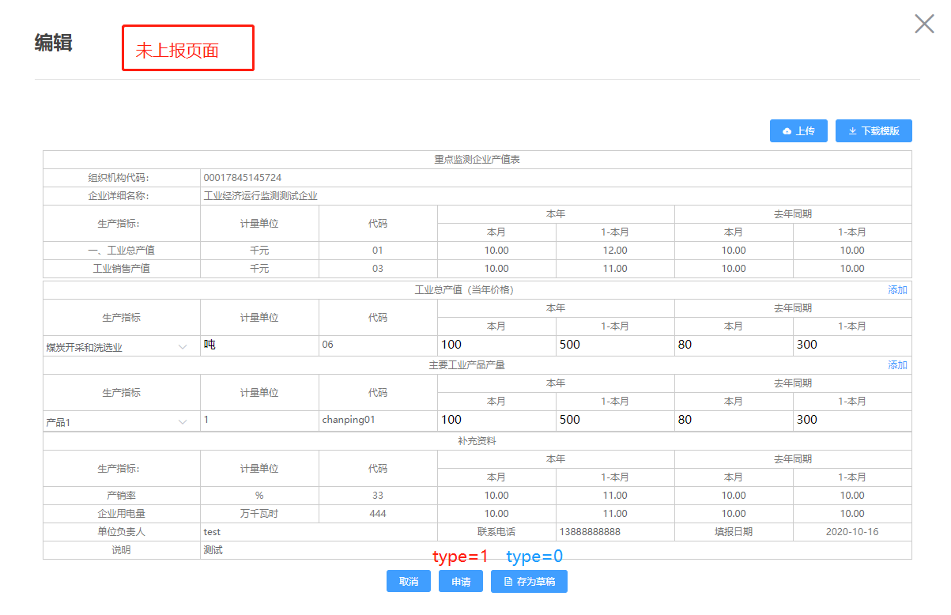
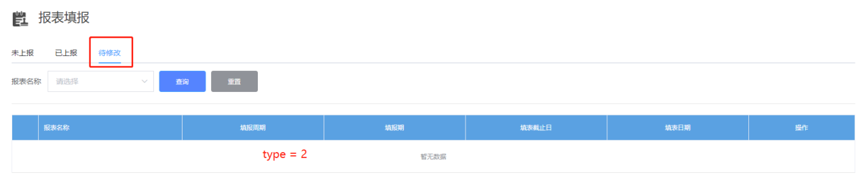

6、申请修改
该接口功能为在已申报页面进行申请修改操作
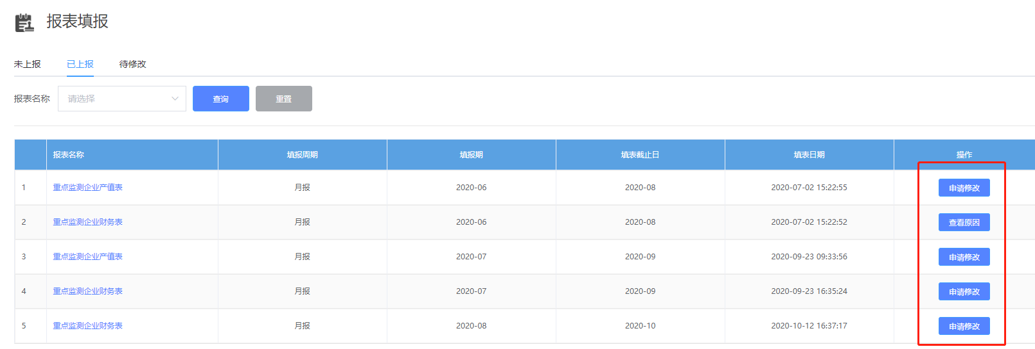
接口：
POST：http://localhost:8776/business/companyForm/applyEdit
传入参数：
{
“apply_reason” : “申请原因”,
“id” : “078856a0-5a8f-47c6-a24d-c4fa43ba5b8a”
}
参数apply_reason是申请原因，id是查询上报列表的主键id，查询企业报表接口会返回。
根据查询企业报表返回的sqxg_status字段判断申请修改状态（0-未申请，1-申请修改，2-修改通过）。

